

Teaching Resources

Table of Contents
Introduction to web accessibility 3
Web usability and accessibility 3
Disability awareness 4
Accessible Canada Act 4
Disability statistics: Infographics 4
Understanding disability 5
Understanding pronouns 5
Internet statistics 6
Testing for web accessibility 7
Vision disabilities 7
Disability simulator 7
Contrast checker 7
Readability: Font choice 7
Designing for accessibility 8
Assistive technology 8
Accessible videos 8
Screen readers 8
Responsive design 9
Inclusive design 9
Movie 11

Introduction to web accessibility

Web usability and accessibility
- Video: Accessible vs. Inaccessible - Can you Hear the Difference?
Demonstration of how the JAWS screen reader announces inaccessible and accessible content. This video also highlights some of the struggles that screen reader users may come across.
- Video: Introduction to Web Accessibility and W3C Standards
This video information is available: in different languages and as a text transcript with description of visuals. W3C provides standards to help make the Web accessible, which are internationally recognized by governments and businesses. Most well-known is the Web Content Accessibility Guidelines (WCAG). WCAG is also ISO 40500, and adopted in the European standard called EN 301 549. It is built around four core principles:
  - Perceivable - for example, so people can see the content, or hear it.
  - Operable - for example, so people can use the computer by typing, or by voice.
  - Understandable - for example, so people get clear and simple language.
  - Robust - so people can use different assistive technologies.
- Infographic of the four principles of WCAG and disability type
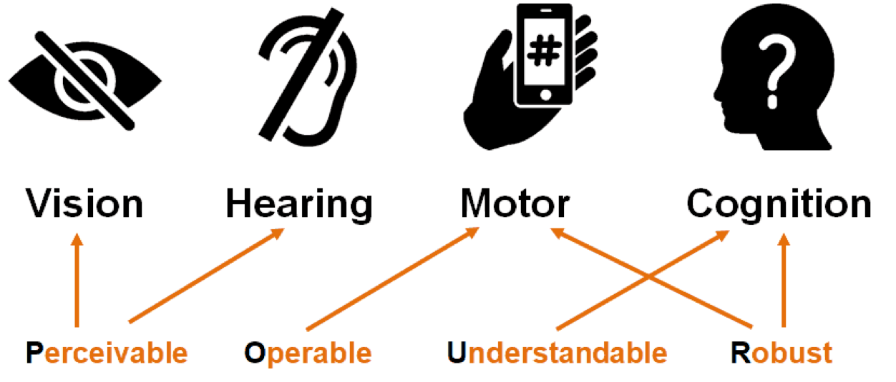
- WCAG Principles (POUR) Infographic

Disability awareness
- Lesson Plans: Increasing disability awareness and sensitivity
This curriculum is intended to promote disability awareness and sensitivity in youth by developing positive images of people with disabilities. The lesson plans provide engaging educational tools to increase knowledge about specific disabilities, address disability stereotypes, and empower students to use positive language in their daily communication.
- WebAIM Cognitive Disability activity
The following activity demonstrates how visual content can supplement text to create a better experience for users, including those with cognitive disabilities.
- Disability Awareness Activity Packet
Activities and resources for teaching students about disabilities.

Accessible Canada Act
- Summary of the Accessible Canada Act (includes an ASL version of the summary)
The Accessible Canada Act recognizes the existing human rights framework that supports equality for people with disabilities in Canada. This includes:
  - the Canadian Charter of Rights and Freedoms
  - the Canadian Human Rights Act, and
  - Canada’s commitments as a State Party to the United Nations Convention on the Rights of Persons with Disabilities
The Accessible Canada Act builds on this framework through a proactive and systemic approach for identifying, removing and preventing barriers to accessibility.
- Accessible Canada Act – visual representations

Disability statistics: Infographics
- Disability in Canada: Facts and Figures
- Canadian survey on disability, 2017: data visualization tool
- Canadians with a mobility disability
- Canadians with a pain-related disability
- Canadians with a seeing disability
- Canadians with mental health-related disabilities
- Educational experiences of youth with disabilities

Understanding disability
- Glaucoma
- Blindness in Canada
- Arthritis Society Facts and Figures
- ADHD Facts
- Dyslexia
- Retinitis pigmentosa
- Hearing loss: types, causes and treatment
- Colour deficiency

Understanding pronouns
- Video: Understanding non-binary

Internet statistics
- Canada’s Internet Factbook 2020
CIRA’s Internet Factbook 2020 provides a lens through which we can see how the early weeks of the pandemic have either shifted behaviours towards the digital sphere, or haven't done so despite the unique circumstances we’re in. This survey of 2,000 adult Canadian internet users was conducted in March 2020 and provides an excellent opportunity to better understand the implications of the pandemic on the way Canadians access the internet and behave online.
- Canadian internet user survey 2020
- Online shopping by Canadians in 2020: Results from the Canadian Internet Use Survey
- Access to the Internet 2020
Access to the Internet at home has become essential for many Canadians who have had to adjust the way they work, study, keep in touch with loved ones, make purchases and use online services during the COVID-19 pandemic.
  - How are Canadians staying connected?
  - How are Canadians spending online?

Testing for web accessibility

Vision disabilities
- Colour blindness test: How well can you see colour?
- Vision loss simulator
See through the eyes of someone affected by glaucoma, cataract, diabetic retinopathy, presbyopia, glare, and macular degeneration - experience the impact these common conditions have on sight.

Disability simulator
- Web disability simulator for Chrome
Simulates how people with disabilities experience the web. Simulation for vision, mobility, read and write, and concentration disabilities. The vision simulation includes colour blindness, farsightedness, tunnel vision, and sunshine. The read and write simulation includes dyslexia and small vocabulary.
- Funkify: Disability Simulator
Funkify is an extension for Chrome that helps you experience the web through the eyes of users with different disabilities.

Contrast checker
- Colour contrast analyser – download
- Contrast checker - online

Readability: Font choice
- Easiest font to read
Change font type, size and check which is easier to read.

Designing for accessibility
- Do’s and don’ts on designing for accessibility
- Infographic: Tips to make accessible websites.
A transcription of the infographic is provided.

Assistive technology
- Video: Assistive Technology
Play the first minute of the video as an introduction to what is assistive technology. Ask students to find an example of assistive technology and describe how users benefit from it.
- What is assistive technology?
Assistive technology includes hardware or software that assists a person with a disability in using the computer to access print and other electronic material.
- Assistive technology for learning disabilities
The most common types of AT used by people with learning disabilities are focused around reading, language, organisational skills, and processing information.

Accessible videos
- Best practices
Videos that illustrate the importance of captions and descriptive video.
  - Students listen to the first video, Frozen - Trailer with Subtitles without seeing the screen. What is the video about?
  - Then, let students listen to the second video, Frozen - Trailer with Audio Description. What do they think now?
  - Finally, let the students watch both of the videos with captions and audio description. Discuss the differences.

Screen readers
- Students can test website using a screen reader on their computer or mobile phone.
  - Assistive Tech: VoiceOver on iOS
  - How to navigate your iPhone with VoiceOver
  - Assistive Tech: TalkBack

Responsive design
- Web page screen resolution simulator
Simulate and test a web page in different screen resolutions.

Inclusive design
- Clear layout and design
Good design includes a good layout and that means a better user experience.
- Good and bad design
Imaginary design by Icons8 to improve the user experience of a boarding pass.

- Additional examples of good and bad designs:
  - Page layout
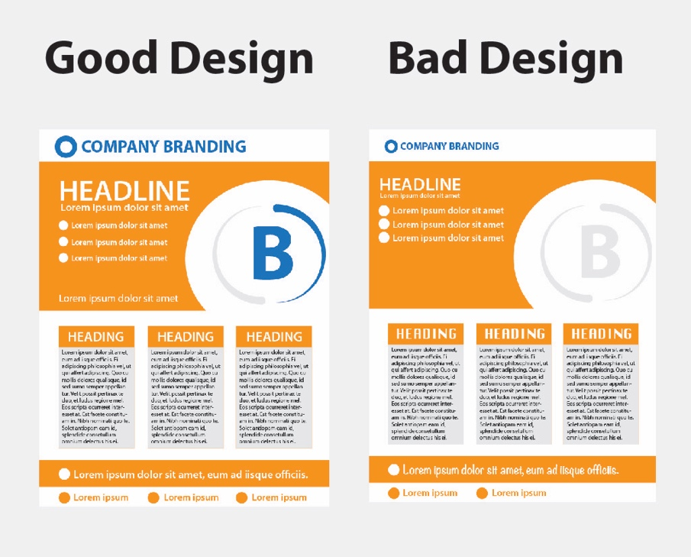
  - Webpages on computer monitors
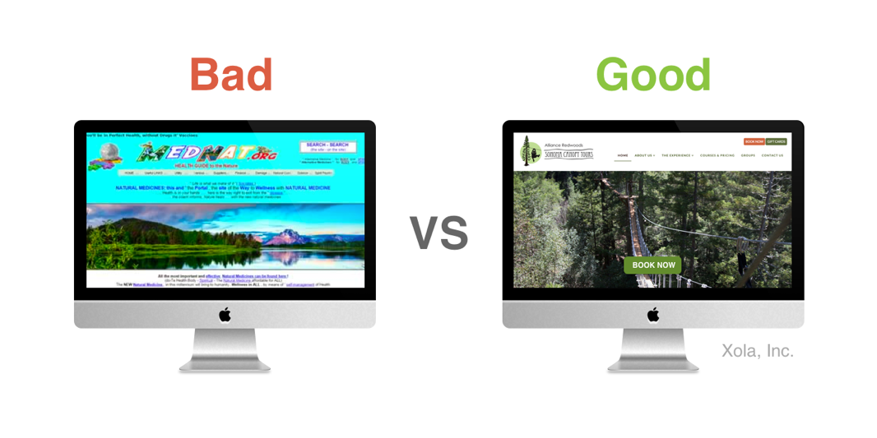
  - Webpages on mobile phones
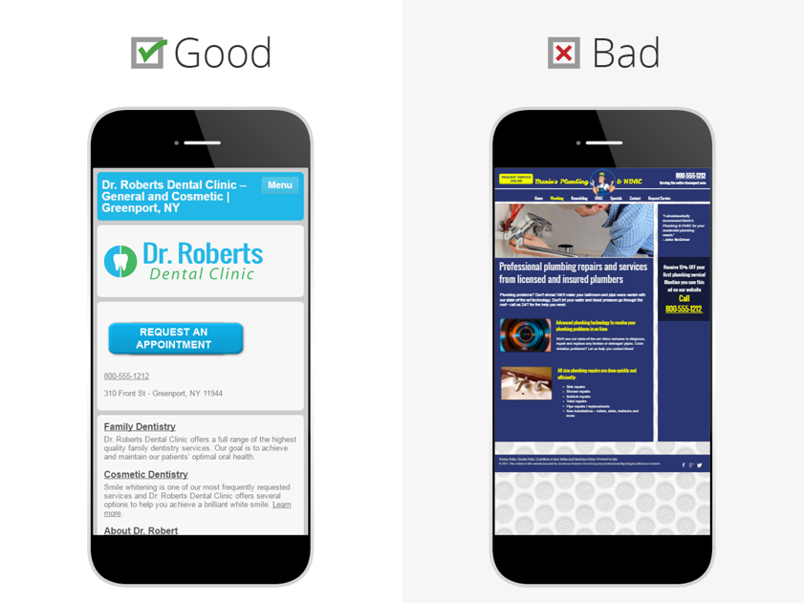

Movie
- Crip Camp: A disability revolution
On the heels of Woodstock, a group of teen campers are inspired to join the fight for disability civil rights. This spirited look at grassroots activism is executive produced by President Barack Obama and Michelle Obama.

https://www.youtube.com/watch?v=5TNU_t-9w1A&t=99s
https://www.w3.org/WAI/videos/standards-and-benefits/
https://mobilityinstitute.medium.com/til-what-is-digital-accessibility-and-why-does-it-matter-3864dc932bc3
https://twitter.com/pa79smyth/status/822349473028378624
http://www.ist.hawaii.edu/products/toolkits/pdf/Disability101.pdf
https://webaim.org/articles/cognitive/activity
https://www.dvusd.org/cms/lib/AZ01901092/Centricity/Domain/1318/Disability%20Awareness%20Packet%202.pdf
https://www.canada.ca/en/employment-social-development/programs/accessible-people-disabilities/act-summary.html
https://www.canada.ca/en/employment-social-development/programs/accessible-people-disabilities/act-infographic.html
https://easterseals.ca/english/wp-content/uploads/2019/10/Disability-in-Canada-Facts-Figures-updated-Oct-2019.pdf
https://www150.statcan.gc.ca/n1/pub/71-607-x/71-607-x2019035-eng.htm
https://www150.statcan.gc.ca/n1/pub/11-627-m/11-627-m2020085-eng.htm
https://www150.statcan.gc.ca/n1/pub/11-627-m/11-627-m2019078-eng.htm
https://www150.statcan.gc.ca/n1/pub/11-627-m/11-627-m2019071-eng.htm
https://www150.statcan.gc.ca/n1/pub/11-627-m/11-627-m2020008-eng.htm
https://www150.statcan.gc.ca/n1/pub/11-627-m/11-627-m2019049-eng.htm
https://cnib.ca/en/sight-loss-infoyour-eyeseye-diseases/glaucoma?region=on
https://cnib.ca/en/sight-loss-info/blindness/blindness-canada?region=on
https://arthritis.ca/about-arthritis/what-is-arthritis/arthritis-facts-and-figures#
https://caddac.ca/understanding-adhd/in-general/facts-stats-myths/
https://www.dyslexiacanada.org/en/dyslexia-basics/
https://cnib.ca/en/sight-loss-info/your-eyes/eye-diseases/retinitis-pigmentosa?region=on
https://www.chha.ca/hearing-education/types-cause-treatment/#Causes
https://opto.ca/health-library/colour-deficiency
https://www.canada.ca/en/treasury-board-secretariat/corporate/news/understanding-non-binary.html
https://www.cira.ca/resources/factbook/canadas-internet-factbook-2020
https://www150.statcan.gc.ca/n1/daily-quotidien/210622/dq210622b-eng.htm
https://www150.statcan.gc.ca/n1/pub/11-627-m/11-627-m2021048-eng.htm
https://www150.statcan.gc.ca/n1/daily-quotidien/210531/dq210531d-eng.htm
https://www150.statcan.gc.ca/n1/pub/11-627-m/11-627-m2019063-eng.htm
https://www150.statcan.gc.ca/n1/pub/11-627-m/11-627-m2019064-eng.htm
http://areyoucolorblind.com/
https://versanthealth.com/visionloss/
https://chrome.google.com/webstore/detail/web-disability-simulator/olioanlbgbpmdlgjnnampnnlohigkjla
https://chrome.google.com/webstore/detail/funkify-%E2%80%93-disability-simu/ojcijjdchelkddboickefhnbdpeajdjg?utm_source=Funkify-free-button&utm_medium=Funkify-web&utm_campaign=Premium-web&utm_content=Premium-free-button&fbclid=IwAR3bGQH0XDpObPy2tdTQTQuuSxZo3Bmf1rYAJcNiFYCtJv9J6JZaeN9mQE0
https://www.tpgi.com/color-contrast-checker/
https://webaim.org/resources/contrastchecker/
https://copywritingcourse.com/easiest-font-to-read/#:~:text=Click%20the%20options%20to%20test%20out%20which%20font,Description%20%7C%20Common%20Pages%20%7C%20Lorem%20Ipsum%20
https://accessibility.blog.gov.uk/2016/09/02/dos-and-donts-on-designing-for-accessibility/
https://visual.ly/community/Infographics/how/infographic-8-tips-make-accessible-websites
https://www.youtube.com/watch?v=DB9pKkZoJDc
http://www2.unb.ca/alc/resources/assistive-technologies.html
https://www.ldao.ca/introduction-to-ldsadhd/what-helps/assistive-technology/
https://accessibilityacrosscurriculum.awolfeworks.com/best-practices-multimedia/videos/
https://www.youtube.com/watch?v=bCHpdjvxBws
https://www.youtube.com/watch?v=qDm7GiKra28
https://www.youtube.com/watch?v=0Zpzl4EKCco
https://smallseotools.com/what-is-my-screen-resolution/
https://www.w3.org/WAI/perspective-videos/layout/
https://logicalcells.blogspot.com/2018/05/10-usability-heuristics-with-examples.html
https://blog.icons8.com/articles/redesigning-boarding-pass-again/
http://tylerpacheco.com/why-you-should-hire-a-graphic-designer/
http://blog.xola.com/zipline-website-conversion-science/
https://blog.hibu.com/mobile-web-design-5-second-checkup/
https://www.youtube.com/watch?v=OFS8SpwioZ4

